Safeguarding at Farnborough Grange

If you have a concern about a child
In an emergency | Call 999
School Designated Safeguarding Lead | Jen Don Carolis
School Deputy Designated Safeguarding Leads | Olivia Dempsey, Tara Lightfoot, Becky Blamires, Kelly Edwards and Amanda Channer
Email | Safeguarding@farnboroughgrange.hants.sch.uk
If a school DSL is unavailable | 0300 555 1373 - Hampshire Children’s Services (Out of Hours)

The Good Shepherd Trust Safeguarding Representatives:
Yvonne McLeod | Chair of the Trust Board and Safeguarding Trustee
Liz Tedbury | Designated Safeguarding Lead for the Trust
Mary Lewis | Trustee Director responsible for Safeguarding

If you have a concern about:
A member of staff | Contact the Headteacher
The Headteacher | Contact Trust CEO, Paul Kennedy (paul.kennedy@goodshepherdtrust.org.uk)
In either case, you can also contact the Local Authority Designated Officer (LADO) for Hampshire using the QR code |  | 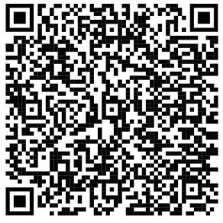
Policy:
Refer to the Child Protection and Safeguarding Policies, which are available on the School Policies page on our website. Hard copies are available from the school office upon request.

Other Contacts:
Ofsted Helpline | 0300 123 1231
NSPCC Helpline | 0808 800 5000
NSPCC Whistleblowing line | 0800 028 0285

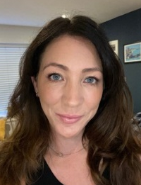 | 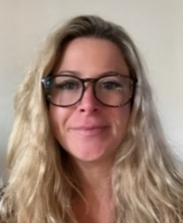 | 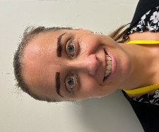 |  |  | 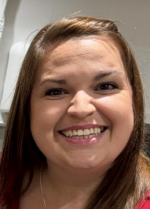
Jen Don Carolis | Olivia Dempsey | Becky Blamires | Tara Lightfoot | Kelly Edwards | Amanda Channer
Early Years Lead | Headteacher | Assistant HT and SENCO | Home-School  Link Worker | Admissions Officer | Trust Operations Manager

